**ADS Editor 1.0**

**Main Display Screen**

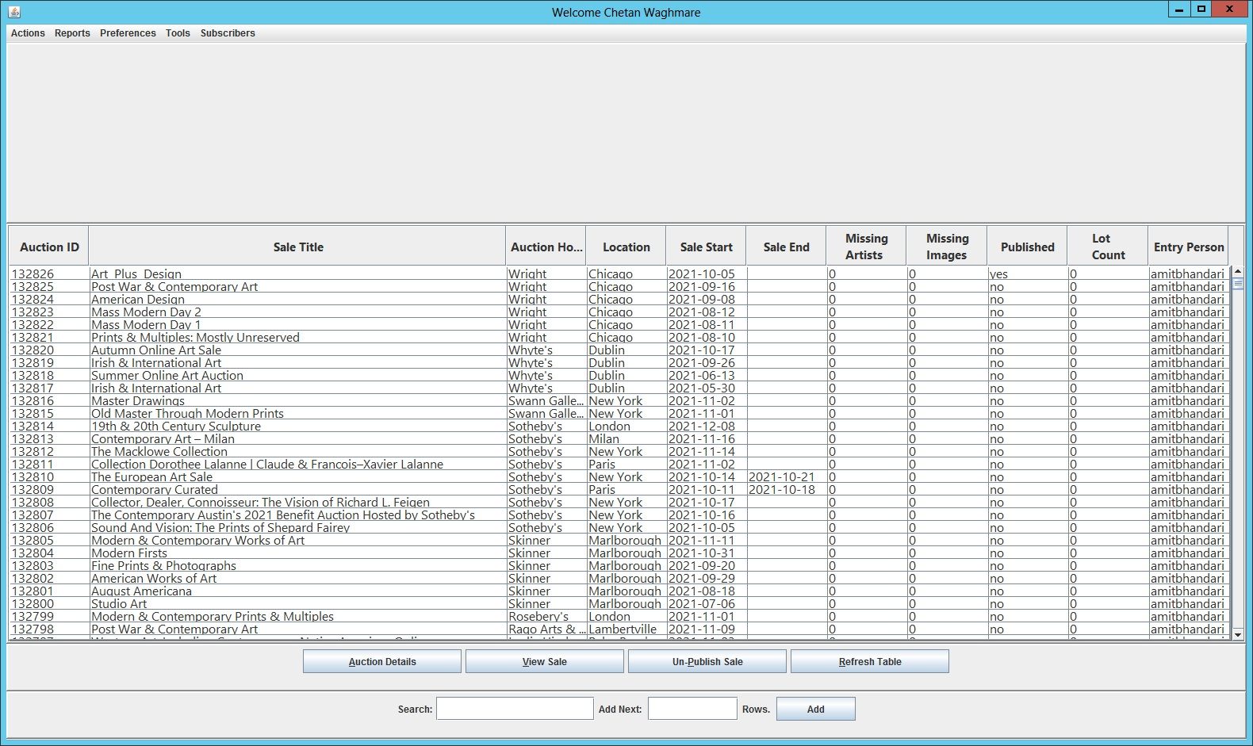

**Auction ID** - The unique auction ID associated with each sale record

**Sale Title** = auction_name

**Auction House** = auction_house_name

**Location** = auction_location

**Sale Start** = auction_start_date

**Sale End** = auction_end_date

**Missing Artists** = Count of lots with which artists are not linked after upload.

**Missing Images** = Count of lots with which images are not linked after upload.

**Published** = Status of the sale, Yes = Live on website & No = not live on website

**Lot Count** = Total lots in a sale

**Entry Person** = User ID of the person who uploaded the sale

**Auction Details Window**

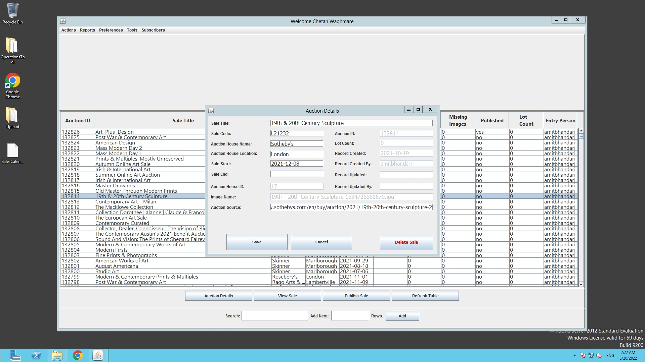

Selecting any record row from the “Main Display Screen” and clicking “Auction Details” button will open up the screen with the editable fields for that sale details.

Sale Title

Sale Code

Auction House Name

Auction House Location

Sale Start

Sale End

Auction House ID

Image Name

Auction Source

**View Sale Window**

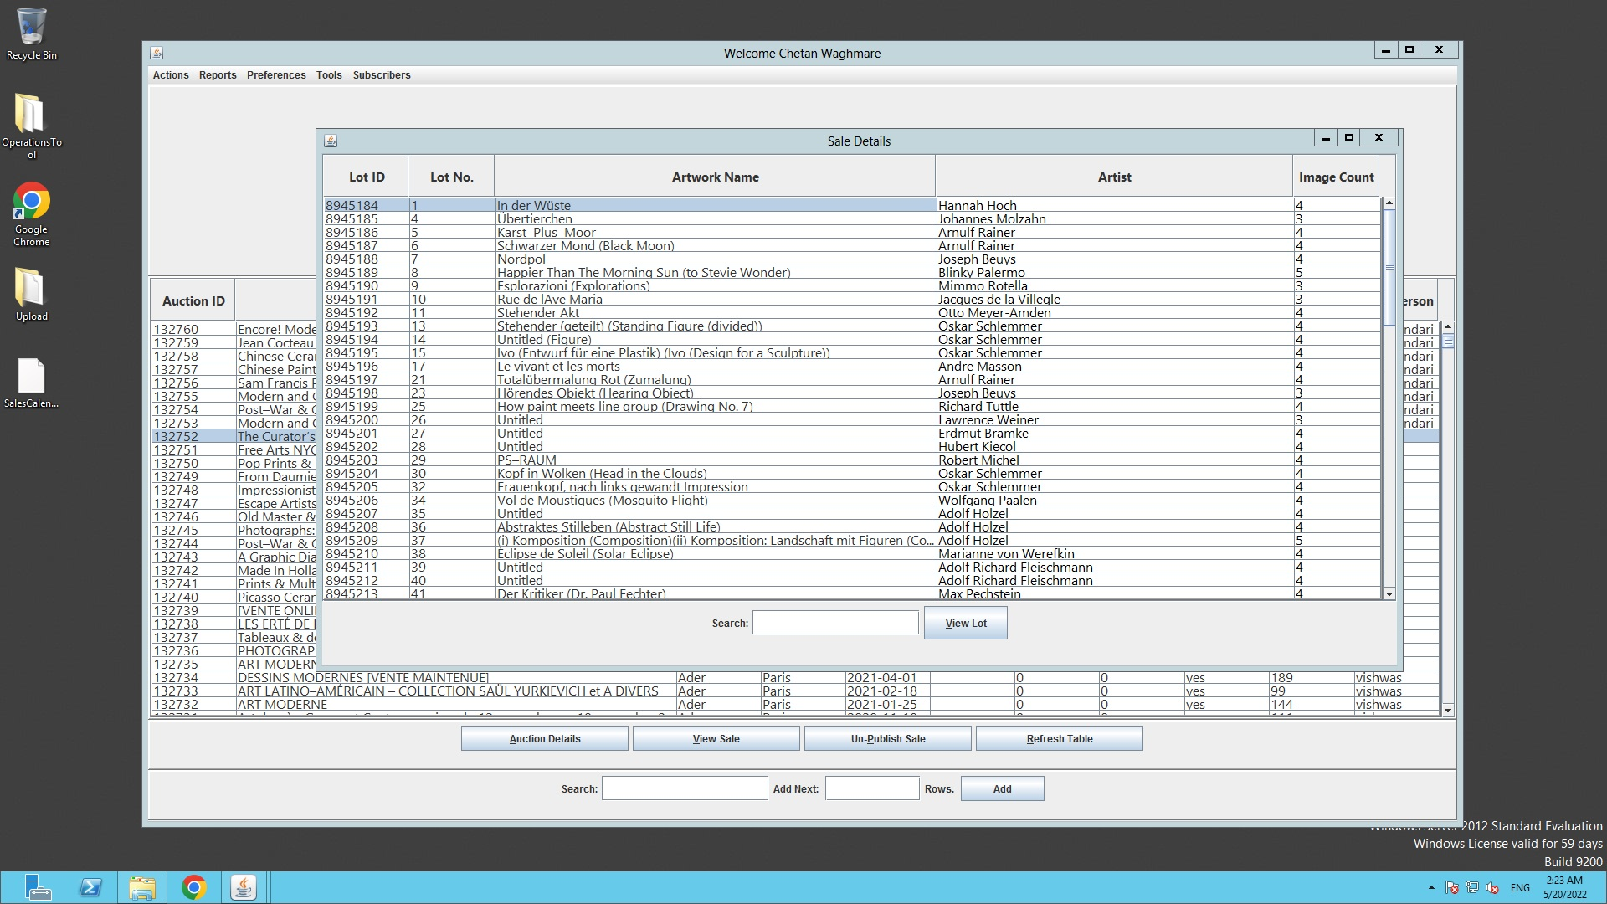

View Sale – Once user selects a sale record on the main display screen and clicks “View Sale” button, it will open the screen with all the lots contained in that sale. It can also be done by a simple double click.

With 5 Coulmns display

1. Lot ID – Unique ID associated with each lot in the database
2. Lot no. = lot_num
3. Artwork Name = artwork_name
4. Artist = artist_name
5. Image Count = Number of images linked with the lot.

**View Lot Window**

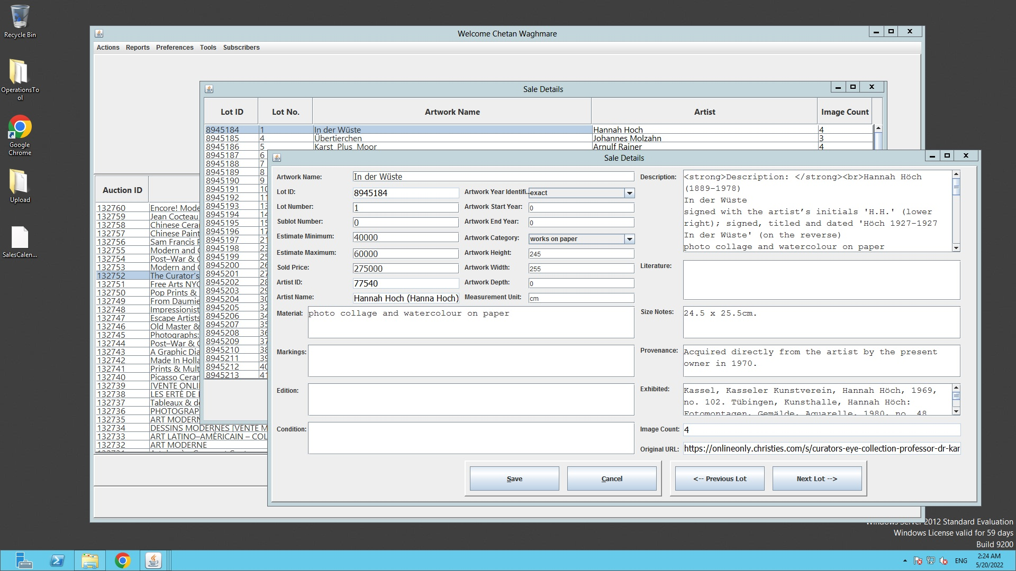

From the View Sale Screen if user selects any record and click “View Lot” button, it will open up the screen with all the lots fields with information in the editable fields (Lot ID will not be editable). It can also be done by a simple double click.

**Artist Linking Window**

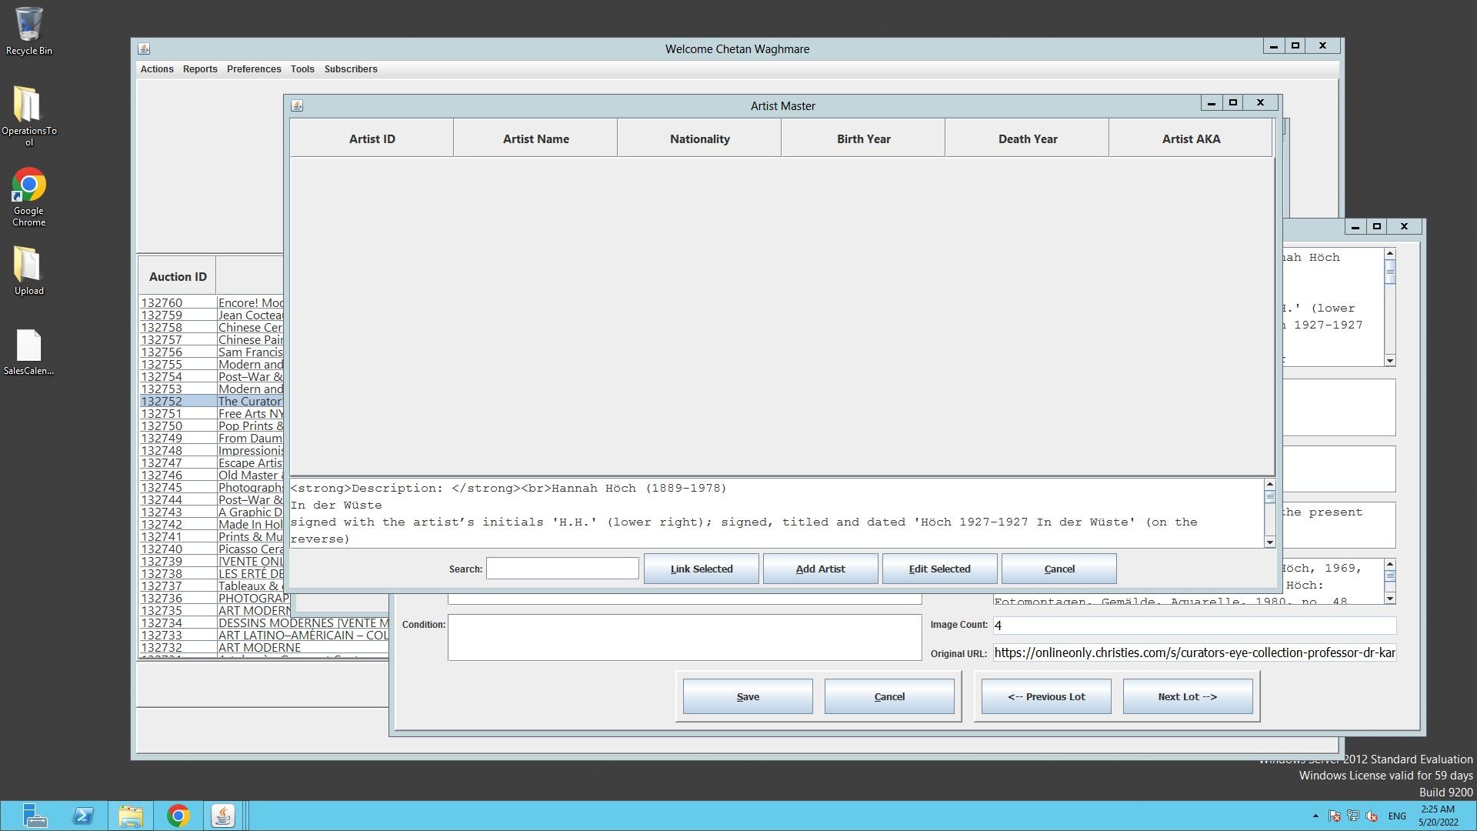

Once user clicks on the artist name field it will open up a new screen to Link/Change the artist record.

**Artist Search Result Window**

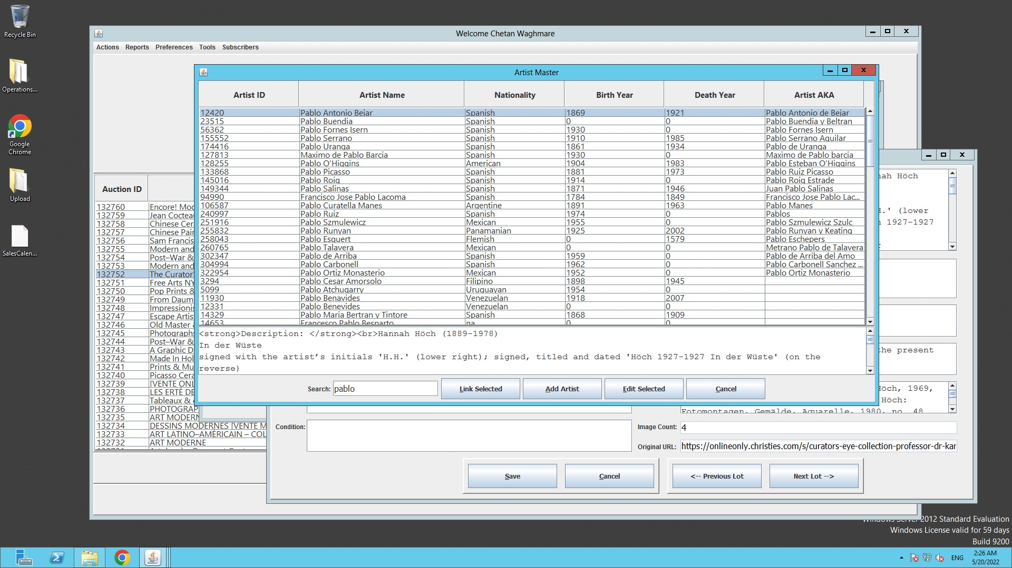

**Artist Search Field** – Search field where user will be able to search the artists from the Database. List of all the similar records with match score greater than 5 will be displayed on the “Artist Search Result Screen” in assending order.

There will be 6 Columns in the Artist Search Result Screen

1. Artist ID
2. Artist Name
3. Nationality
4. Birth Year
5. Death Year
6. Artist AKA (alias name of the artists present in the Database)

Selecting any record and clicking on “Link Selected” button will link the selected artist to the lot and then clicking the “Save” button on the Lot Details Screen will update the new artist record with that lot. In case there is already an artist linked to the lot then it will replace the previous record with the selected one.

**Add Artist Window**

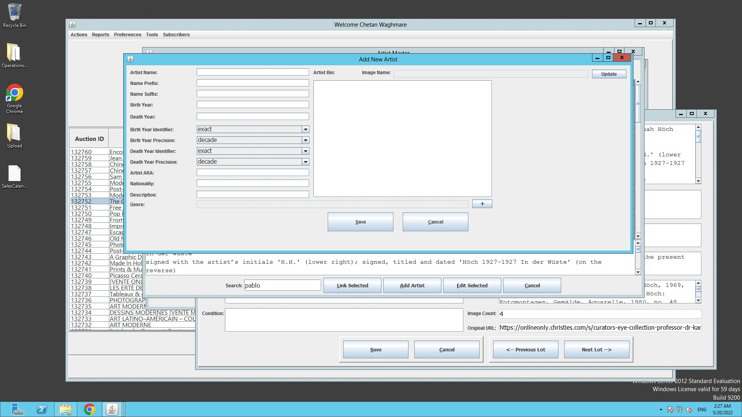

In case no record found in the database by the user, there is an option to create/generate a new artist record by giving the required details in the “Add New Artist” screen.

**Edit Selected Artist**

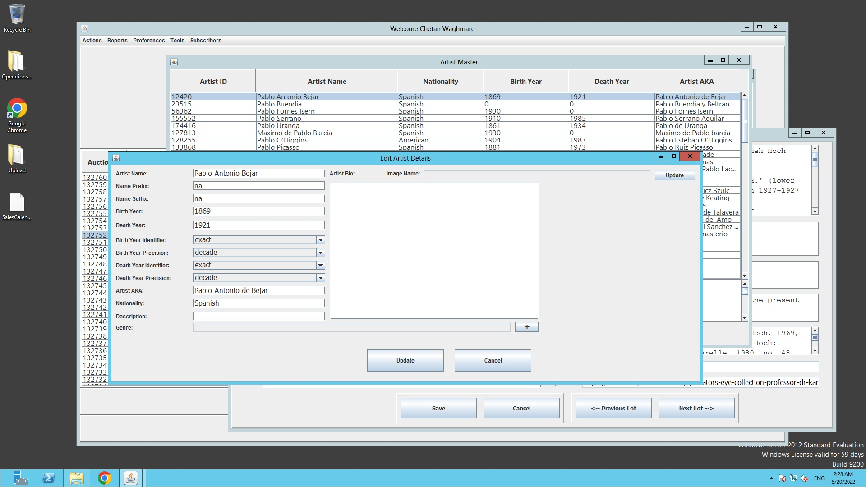

In case user wants to change/modify the existing artist record or add more details to the selected artist then there is an option of “Edit Selected” under “Artist Linking Window”. It will give the editable fields as shown in the “Edit Artist Details” screen.

**Missing Artist Image Indicator**

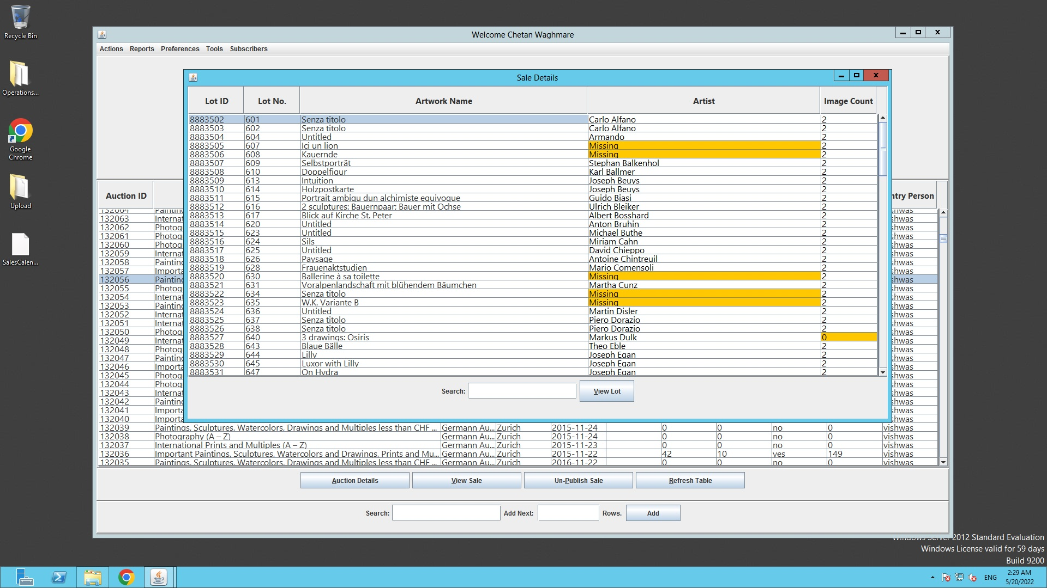

After uploading any sale data to the database their will be some artists records will not get linked as they were failed to match with the existing database records due to any reason.

In case of the Failure to match the artist from the uploading data to the database, the lot will get linked to the “Missing” records in place of artist.

The Missing record with be displayed in a highlighted Orange color.

Same will be with the 0 count for the image, i.e if no image linked to the lot and the count says 0 then it will be highlighted in Orange color.

**Action Drop Menu**

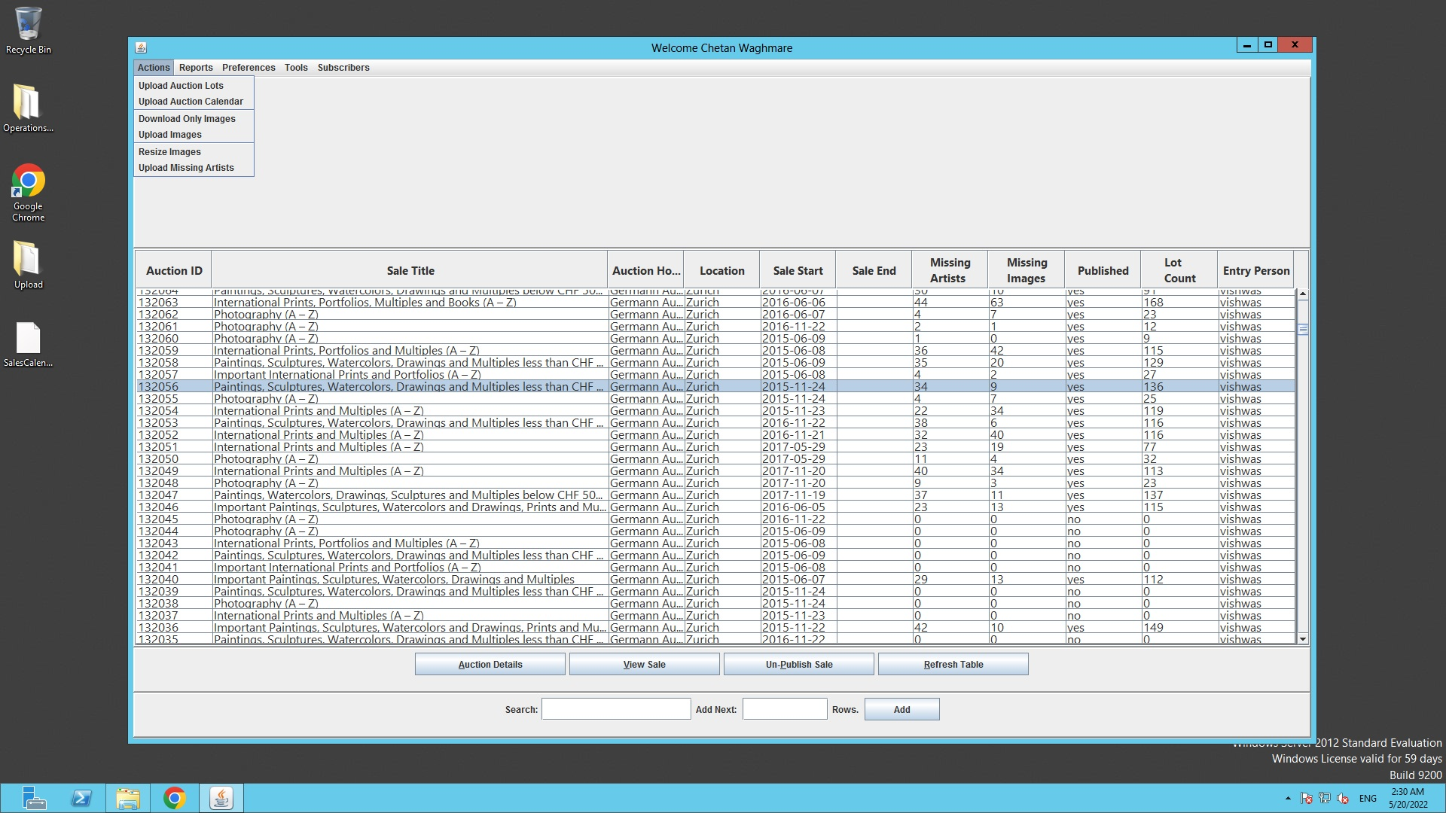

On the top menu bar there will be an “Action” tab which will give the below Action Triggers.

1. **Upload Auction Lots** – Selecting a particular csv file and uploading the data to the database. It will upload the data from the csv and download the images from the image urls on the local machine, which will be uploaded in the second step.
2. **Upload Auction Calendar** – Selecting a particular csv file of Auction Calendar Format and uploading the data to the database. It will upload the data from the csv and download the images from the image urls on the local machine, which will be uploaded in the second step.
3. **Download Only Images** – Selecting a particular csv file and download only the images, no data uploading with this trigger.
4. **Upload Images** – Uploading of images which are downloaded from Auction lots and Auction Calendar uploading.
5. **Upload Missing Artists** - Selecting a particular csv file of Missing Artists Format and uploading the data to the database, generating new artists records.

**Tools Drop Menu**

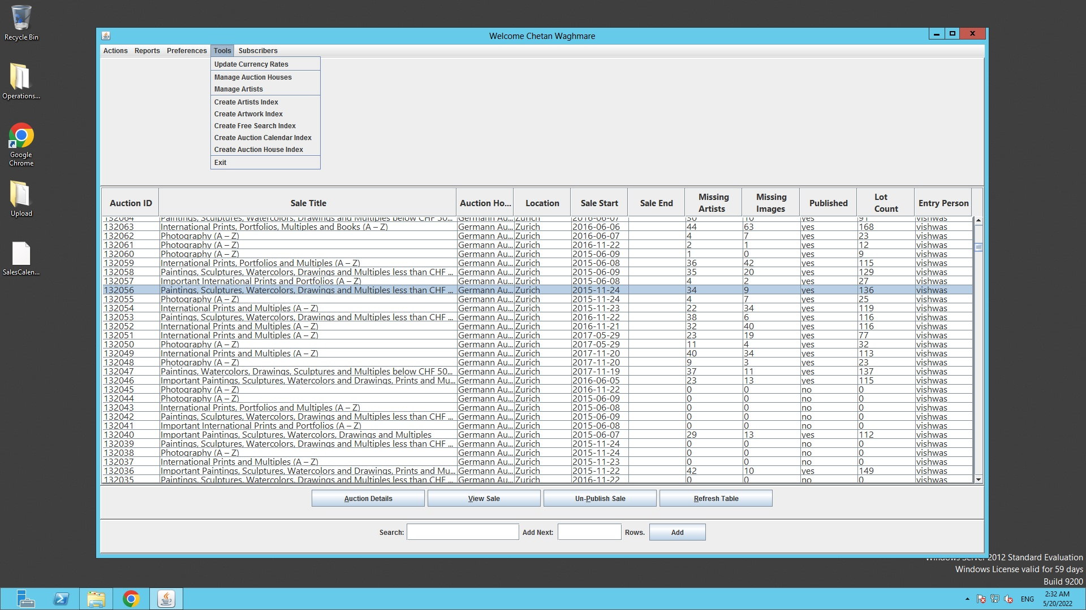

Under Tool Drop Menu

1. **Update Currency Rates** – Updation for the currency conversion rate can be done from this trigger using the required formatted file.
2. **Manage Auction Houses** – Give a list of Auction Houses with Edit options, please see the screen below.
3. **Manage Artists – Gives** Artists Master Window which is explained above with the Edit options, please see the screen below.

**Manage Auction Houses Screen**

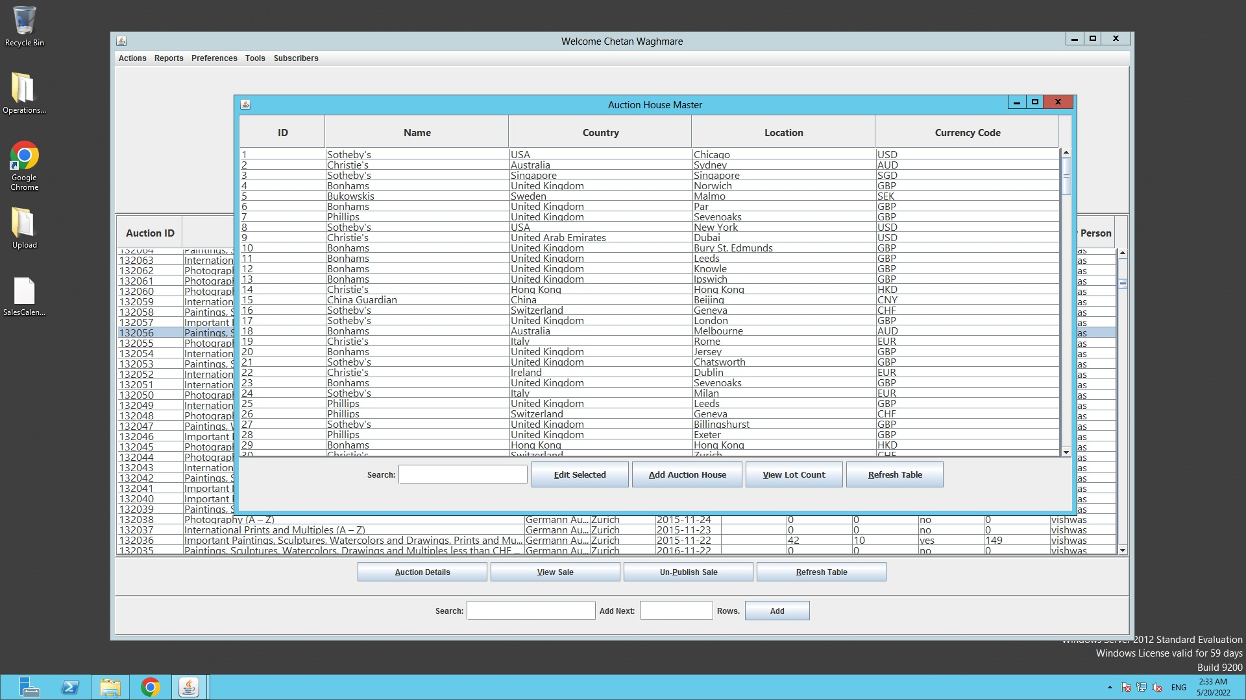

**Edit Selected Window**

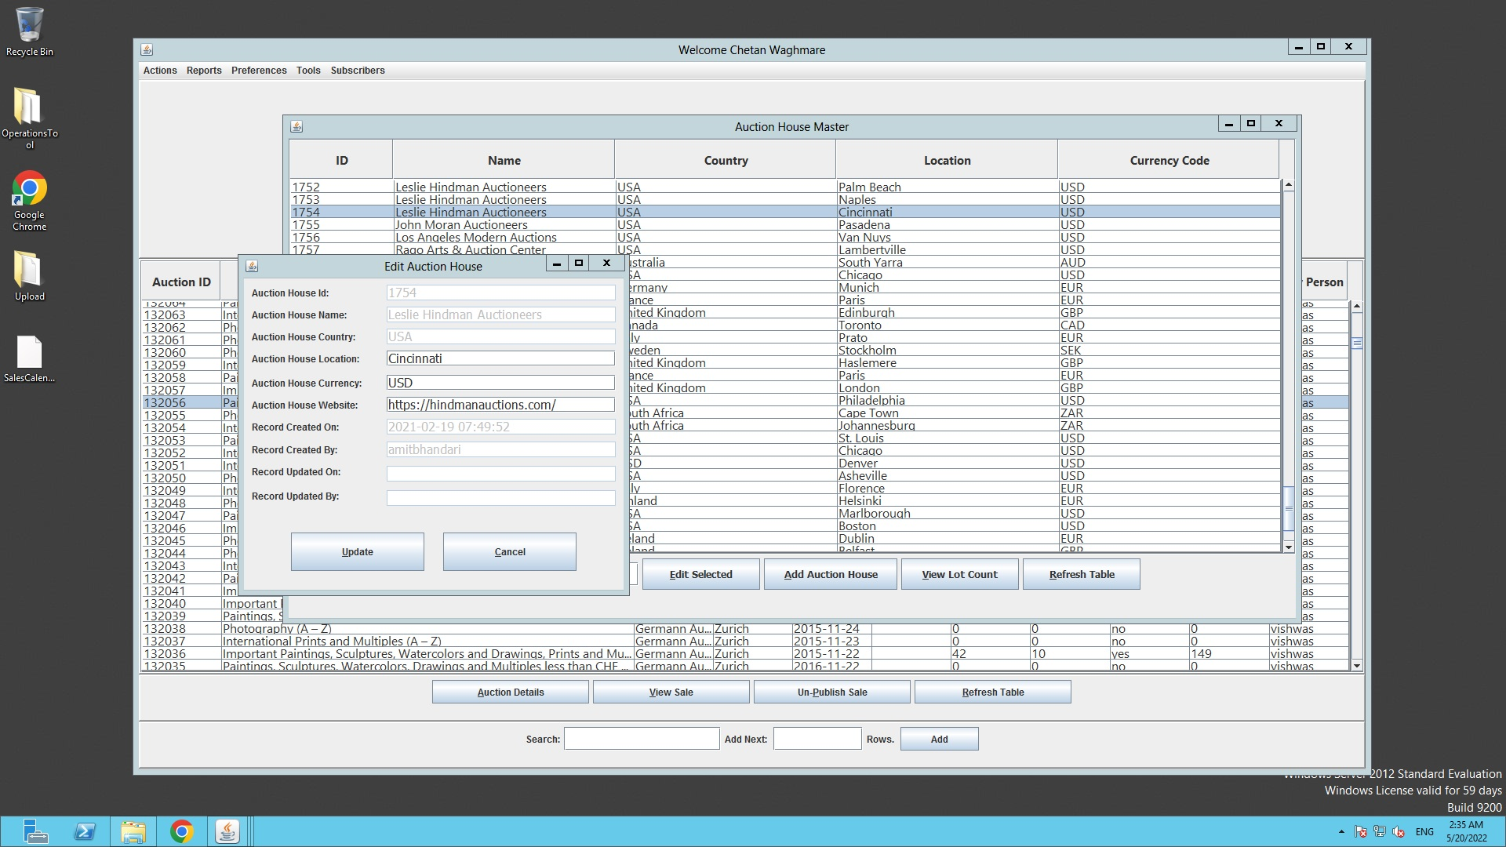

**Add New Auction House Window**

